Cruise System Trajectory Generator

25 March 2003

Thomas W. De Vries

1.0 Introduction

This document provides some requirements for a computer program which will generate trajectory parameters for use in cruise system error analysis programs. Cruise systems include vehicles such as aircraft, helicopters, and cruise missiles. The program is not designed to generate trajectory data for ballistic or orbital systems.

The purpose of the program is to provide the coefficients which are required for the differential equations which describe the error propagations in an inertial navigation system, and for the transition matrix in Kalman filter analyses. These coefficients include the body angular rates, and possibly the body sensed accelerations, which are needed for the analysis of strapdown inertial navigation systems. Other data which can be computed include the Earth Centered Earth Fixed (ECEF) position vector of the system, for use with GPS/INS integration filters.

2.0 Coordinate Systems

A North-East-Down (NED) coordinate system is used for the majority of the outputs from the trajectory generator, to keep the trajectory data independent of the coordinate system used for the error analyses. Geodetic position is given by latitude, longitude, and altitude above the geoid, and vehicle body attitude is defined by the Euler angles: true heading (positive CW from north), pitch (positive nose up), and roll (positive right wing down). The body coordinate axes are X forward, Y right, and Z down.

3.0 Path Definition

The path of the vehicle is defined by a set of initial conditions, and a number of path segments. Depending on which option is selected, the segments can be either constant-heading rhumb lines or great circles. The initial conditions include initial latitude and longitude, but no attempt is made to terminate the path at a specific final latitude and longitude.

3.1 Initial Conditions

The following are typical initial conditions for the path:

1. Latitude, 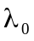
2. Longitude, 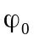
3. Altitude, 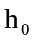
4. Total velocity, 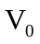
5. Heading, 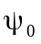
6. Pitch (normally zero), 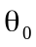
7. Roll (normally zero), 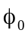
8. Heading rate limit (for runway or stationary turns), 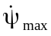
9. Pitch rate limit, 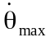
10. Roll rate limit, 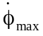
11. Segment types (rhumb line or great circle)
12. Number of segments, m

3.2 Segment Specifications

Changes in segment conditions, such as heading, velocity, or altitude, are assumed to occur at the start of a segment. If rhumb line segments are specified, the specified final heading of the segment is the heading from north. If great circle segments are specified, the specified final heading of the segment is relative to an azimuth wander coordinate frame which is initialized with a zero wander angle at the start of the path. In either case, the change in heading at the start of a segment is computed from the difference in the specified heading of consecutive segments.

The parameters which specify the 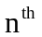segment should include the following:

1. Final time, 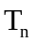
2. Time step, 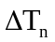
3. Final heading, 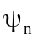
4. Centripital turn acceleration (g’s), 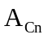
5. Final total velocity, 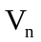
6. Longitudinal acceleration (g’s), 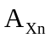
7. Final altitude, 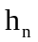
8. Altitude rate, 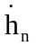
9. Vertical acceleration (g’s), 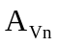
10. Pitch angle (climb or dive), 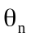

The path time starts at zero, and the final time 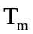specified for the last segment will be the end time of the trajectory.

Turns occur at the start of a segment, and can be modeled either as coordinated or flat turns, depending upon how the centripetal acceleration of the turn is specified. Positive values of centripetal acceleration can be used to indicate a coordinated (banked) turn, negative values can be used to indicate a flat (unbanked) turn, and a zero value can indicates that the heading rate limit specified in the Initial Conditions is to be used to generate a flat turn. The centripetal acceleration is assumed to lie in the level plane.

To simplify calculations for the coordinated turn case, the heading rate used to generate the turn is assumed to begin at the start of the segment, simultaneous with the roll rate needed to achieve the desired bank angle for the turn. The roll rate back to a level position is assumed to begin at the start of the last time step before the final heading has been achieved.

The total velocity of the vehicle is specified. The total velocity is resolved through the pitch and heading angles to obtain NED components.

The longitudinal acceleration is used to compute changes in the total velocity at the start of a segment. This acceleration is assumed to act along the X body axis of the vehicle.

When a change in altitude occurs between two consecutive segments, the change can be achieved by either a climb or dive with a non-zero pitch angle, or a vertical velocity with zero pitch angle as might be the case for a helicopter. The specified vertical acceleration is used to compute the rate at which the vertical velocity is achieved for either condition. If a pitch angle is specified, the vertical velocity is computed from the specified total velocity, and the specified altitude rate is not used. The vertical acceleration in this case may be limited by the pitch rate limit specified in the Initial Condition
.
The calculation of the time at which to start the pitch rate back to level at the end of a climb or dive is rather complicated when constant pitch rates are used. Therefore the logic in the following sections uses constant vertical acceleration and deceleration, which are adequate for most error analysis purposes.

4.0 Calculation Method

The generation of the trajectory starts with the calculation of body attitude. If a heading or altitude change is specified, values of heading, pitch, and roll are determined at the time point of the trajectory. If no changes are specified, pitch and roll are assumed to be zero, and heading is computed based on either a rhumb line or great circle segment. Next, NED velocity components are computed, assuming that the total velocity lies along the X body axis. The vehicle drift angle and angle of attack are assumed to be zero. Trapezoidal velocity integration is used to extrapolate position, and consecutive velocities are differenced to give average velocity rates over the trajectory time step. Finally, Coriolis and gravitational accelerations are combined with the velocity rate to give average sensed acceleration in NED axes.

A coordinate transformation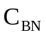from NED Navigation to Body axes is computed from the heading, pitch, and roll angles, and consecutive values of this matrix is used to compute average values of the body angular rates. Consecutive values of this transformation can also be averaged and used to transform the average sensed NED accelerations into average Body axis components.

The following sections give more detailed equations for these calculations.
5.0 Initializations

5.1 Attitude

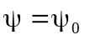 heading
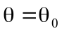 pitch
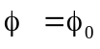 roll
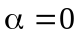 wander angle

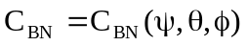 use subroutine

5.2 Velocity

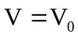 total

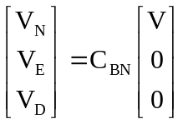 NED components

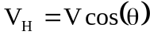 horizontal
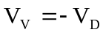 vertical (+ up)

5.3 Position

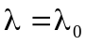 latitude
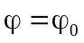 longitude
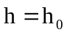 altitude

5.4 Gravity

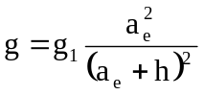 approximate gravity model

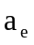= 6378137 meters
See 6.13 for 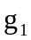

5.5 Sensed Acceleration

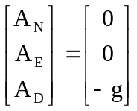 no Coriolis acceleration

5.6 Body Rates

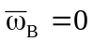 no earth rates

5.7 Time

T = 0 start time at zero

5.8 Segment Index

n = 1 first segment
6.0 Segment Calculations

6.1 Time Logic

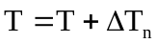 boost time

If 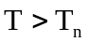 then test for end of segment
If n < m then test for more segments
n = n + 1 boost segment index
Else
Done end of trajectory
End if
End if end of segment test

6.2 Heading Change Logic

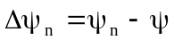 required heading change
If 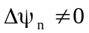 then test for non-zero change
If 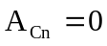 then turn acceleration not specified
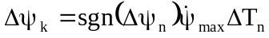 flat turn at specified rate
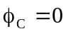 commanded roll = 0
Else turn acceleration specified
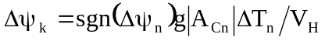 heading change at specified g level

If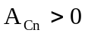 then test for positive turn acceleration
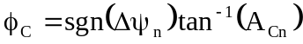 coordinated turn roll angle
Else
flat turn
End if end of turn acceleration test
End if end of turn type test

If 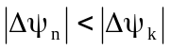 then test for end of turn
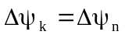 complete turn
set commanded roll to zero
End if

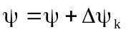 extrapolate heading

End if
6.3 Roll Change Logic

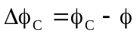 required roll change

If 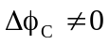 then test for non-zero change
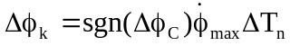 roll change at specified rate

If 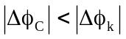 then
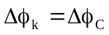 last time step
End if

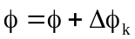 extrapolate roll
End if end if roll change test

6.4 Altitude Change Logic

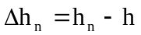 required altitude change

If 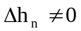 then test for altitude change

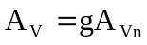 specified vertical acceleration

If 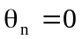 then test for zero pitch angle
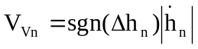 vertical velocity (+ up)
Else
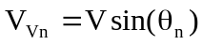 vertical velocity from pitch
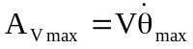 vertical acceleration limit
If 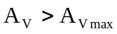 then
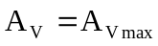 limit the vertical acceleration
End if
End if end of pitch angle test

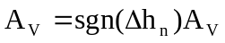 attach correct sign to vertical accel
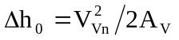 deceleration distance
If 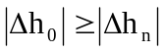 then test for start of deceleration
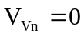 set desired vertical velocity to zero
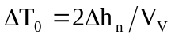 deceleration time
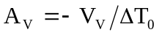 deceleration value
Else
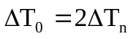 set for last time step test
End if end of deceleration test

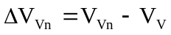 required vertical velocity change

If 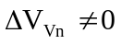 then test for velocity change

If 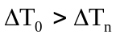 then test for last time step
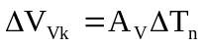 velocity change
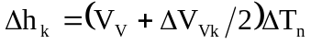 altitude change
Else last time step
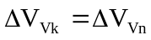 last velocity change
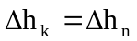 last altitude change
End if

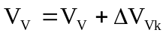 extrapolate vertical velocity
End if end of velocity change test

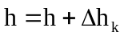 extrapolate altitude

End if end of altitude change test

6.5 Velocity Change Logic

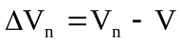 required velocity change

If 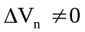 then test for velocity change
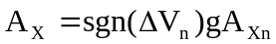 specified acceleration
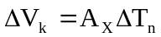 specified velocity change

If 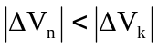 then test for last time step
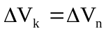 last velocity change
End if end of last time step test

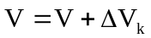 extrapolate velocity
End if end of velocity change test

6.6 Pitch Angle

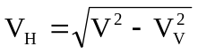 horizontal velocity

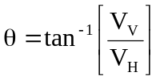 pitch

6.7 Relative Rates

These calculations are exact for an oblate earth.

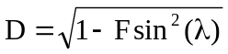

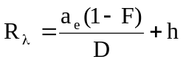 north-south radius of curvature

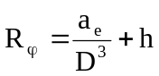 east-west radius of curvature

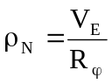 north relative rate

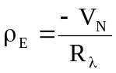 east relative rate

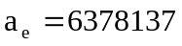 meters
F = 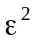 = 6.69437999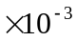

For rhumb line path segments:

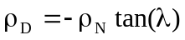 down relative rate

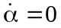
For great circle path segments:

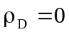

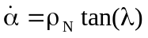 wander angle rate
6.8 Navigation to Body Transformation

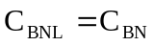 store previous transformation

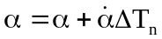 extrapolate wander angle

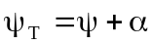 true heading from north

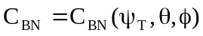 use subroutine

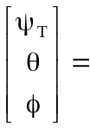 trajectory Euler angles (heading, pitch, roll)

6.9 Velocity Calculations

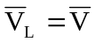 store previous velocities

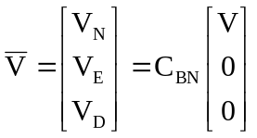 trajectory navigation velocities

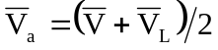 average velocities

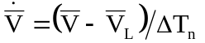 average velocity rate

6.10 Position Calculations

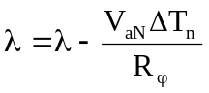 extrapolate latitude

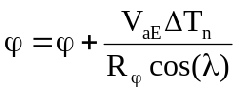 extrapolate longitude
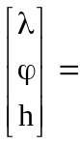 trajectory geodetic position (latitude, longitude, altitude)

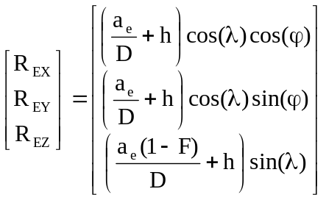 trajectory ECEF position vector

6.11 Inertial Angular Rates

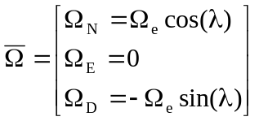 earth rates

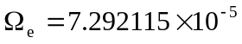 rad/s

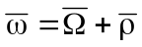 total spatial rates

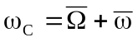 Coriolis rates

6.12 Average Sensed Accelerations

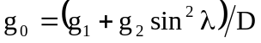 Somigliana gravity formula

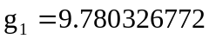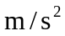
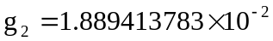

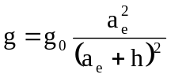 altitude effects

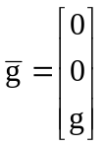 gravity vector

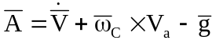 navigation sensed accelerations

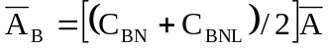 body sensed accelerations
6.13 Average Body Rates

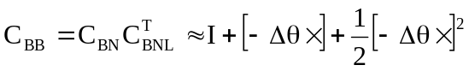 body rotation matrix, 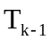 to 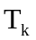

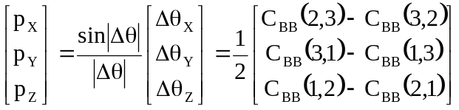 approximate body angle changes

In most cases, when the rotation angles are small over the trajectory time step, the vector can be used to compute average body rates with respect to the earth:

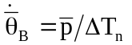

A more accurate solution is also possible, as follows:

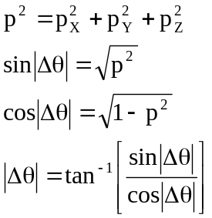 solve for angle change magnitude

The following approximation can also be used for 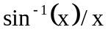

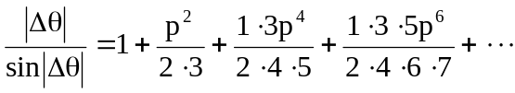
In either case:

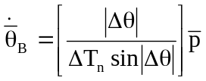 average body rates wrt the earth

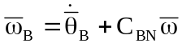 trajectory average body inertial rates
7.0 Trajectory Output File Format

This section shows a typical output file record format that is compatible with a number of Autonetics error analysis programs. However, other formats certainly are possible, and can be adapted to specific applications. The first output record should be at time 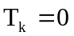, based on the specified initial conditions for the trajectory.

Number Symbol Data Units Notes

1 Time seconds
2 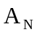 North Sensed Acceleration meters/sec² 1
3 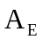 East Sensed Acceleration meters/sec² 1
4 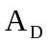 Down Sensed Acceleration meters/sec² 1
5 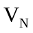 North Velocity meters/sec
6 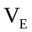 East Velocity meters/sec
7 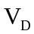 Down Velocity meters/sec
8 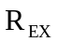 X ECEF Position meters
9 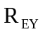 Y ECEF Position meters
10 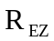 Z ECEF Position meters
11 Latitude radians
12 Longitude radians 2
13 h Altitude meters
14 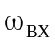 X Body Rate rad/sec 1
15 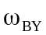 Y Body Rate rad/sec 1
16 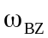 Z Body Rate rad/sec 1
17 Roll radians 2
18 Pitch radians
19 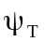 True Heading radians 2

Notes:
1. Average value, to

2. Reduce to the range 

